**1. The Purpose of the Project**

* **1a. The User Business or Background of the Project Effort**
* **1b. Goals of the Project**
* The goal of the product is to produce a product in which a user can feel comfortable, confident and successful when surveying and selecting one of our questions. The goal for each question is to be straightforward and thorough, thus allowing the user the freedom to decide which question to pick. A result of the question will allow the user to know more about themselves, but in a good way.

Service goal: The customer will feel satisfaction and well-being after choosing and answer from our website.

* + **2. The Stakeholders**
* **2a. The Client**
* **2b. The Customer**

It is presumed that the customer is a fully capable human being with the ability to understand directions and operate a computer. The customer is also literate and fluent in English.

* **2c. Other Stakeholders**
* **2d. The Hands-On Users of the Product**
* **2e. Personas**

Personas very the customer could be anyone between the ages of 5-99. We could see young children eager to answer something or an elderly person scouring though questions.

* **2g. User Participation**

The website will require full participation from users when choosing and answering a question.

* **2h. Maintenance Users and Service Technicians**

**4. Naming Conventions and Terminology**

* **4a. Glossary of All Terms, Including Acronyms, Used by Stakeholders involved in the Project**

User Cases: A diagram the represents the flow of the website from a user’s perspective. Text Box: An area defined to hold and store the answer from users.

**5. Relevant Facts and Assumptions**

* **5a. Relevant Facts**
* **5b. Business Rules**
* **5c. Assumptions**
* Assumptions: Literate, Human, visual disabilities, fluent in English.

**6. The Scope of the Work**

* **6a. The Current Situation**
* The website is for users who are wanting, willing or interested in answer unique questions.
* **6b. The Context of the Work**

**8. The Scope of the Product**

* **8a. Product Boundary**
* **8b. Product Use Case Table**

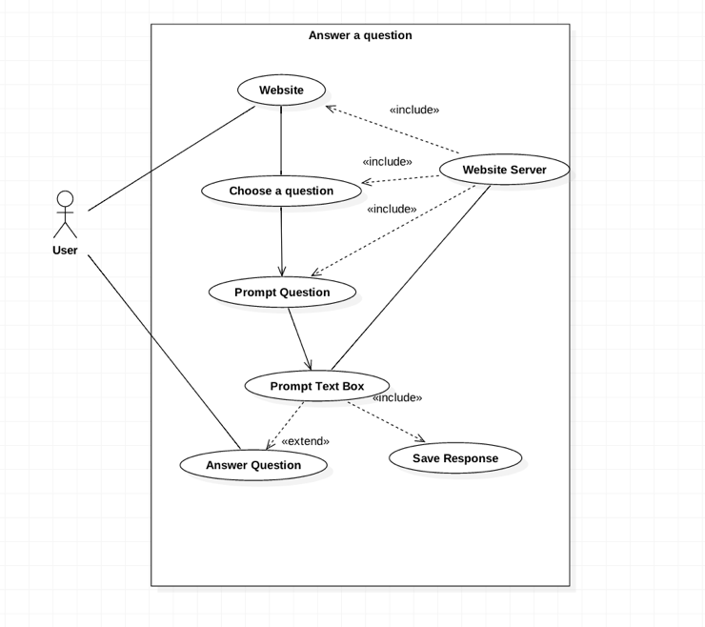

* **8c. Individual Product Use Cases (PUC’s)**

**9. Functional Requirements**

Functional requirements are the fundamental or essential subject matter of the product. They describe what the product has to do or what processing actions it is to take.

* **9a. Functional Requirements**
* Text boxes will be a result of the program as well as submit.
* Answer will be stored into server results from program.

**10. Look and Feel Requirements**

Nonfunctional requirements (sections 10-17) are the properties that the functions must have, such as performance and usability. Do not be deterred by the unfortunate type name (we use it because it is the most common way of referring to these types of requirements)—these requirements are as important as the functional requirements for the product’s success.

* **10a. Appearance Requirements**

Website will be a simple and unique design, designed to grab the user’s attention.

* **10b. Style Requirements** As for font it will be a simple eye please font and size. Either Times New Roman or Ariel at a reasonable 14-16 font size.

**11. Usability and Humanity Requirements**

This section is concerned with requirements that make the product usable and ergonomically acceptable to its hands-on users.

* **11a. Ease of Use Requirements**

**Content**

* + Efficiency of use: The website will be deigned with simplicity as a factor. Simple navigation and answering.
  + Ease of remembering: The user should be able to remember the ease at which a question is selected and answered.
  + Error rates: Looking to accomplish a 100% error free website.
  + Overall satisfaction in using the product: Should be satisfying to users.
  + Feedback: A little section called feedback will be available at all time on the web page. There users can five feedback on anything thing they have seen.

**Motivation**

To guide the product’s designers toward building a product that meets the expectations of its eventual users.

**Fit Criterion**

These examples may seem simplistic, but they do express the intention of the client. To completely specify what is meant by the requirement, you must add a measurement against which it can be tested—that is, a fit criterion. Here are the fit criteria for the preceding examples:

It shall be complete in about 2-3 weeks max. The goal is to test the website on different age groups can test the website for about 15-30 minutes.

**Considerations**

* **11b. Personalization and Internationalization Requirements**

**Content**

English questions for all ages.

**Motivation**

To relieve the need to answer unique and ambiguous questions.

**Examples**

The website will present simple questions that will engage the user.

Questions will aim away from personal, and political views.

**Considerations**

The product is not restricted to one Nation or culture. It’s meant for anyone to use. Our only catch is that English is the primary language of the product.

We are willing to work with translators to increase the versatility and usage from other Nations and Cultures.

* **11c. Learning Requirements**

**Content**

The product is simple, but we do ask that users know there way around the Internet and Computers.

**Examples**

The product will be easy to use for users with computer and Internet experience. If user are not experience then the product is simply enough to guide the users.

**Fit Criterion**

**Considerations**

* **11d. Understandability and Politeness Requirements**

This section is concerned with discovering requirements related to concepts and metaphors that are familiar to the intended end users.

**Content**

The question will be simple and straight to the point. We are not trying to confuse anyone by our wording.

**Motivation**

To promote user to engage with the product and the simplicity of it. The user should feel engaged when traversing through the library of questions.

* **11e. Accessibility Requirements**

**Content**

**Motivation**

**Examples**

**14. Maintainability and Support Requirements**

* **14a. Maintenance Requirements**
* **14b. Supportability Requirements**
* **14c. Adaptability Requirements**

**21. Tasks**

* **21a. Project Planning**
* **21b. Planning of the Development Phases**

**27. Ideas for Solutions**

A solution to the product is a website that is capable of present a simple question, the question can be chosen by the user. But an example question will be presented at the main page, stating “What pet is better cats or dogs?”. The purpose is present a question that will result in the user learning more about themselves.